- Project Profile
Project Name: | Virtual Tech Culture
Type of Application: | Web based application
Project Description: | It is educational website for students, where they can refer, download various materials and can give quiz. This provide a good source of knowledge to students who are interested in IT.
Team Size: | 3
Front End: | PHP, HTML, CSS, Bootstrap
Back End: | MySQL
Documentation Tools: | Microsoft Office

- Introduction to Tools
- Front End Tool:
  - HTML:
Hypertext markup language (HTML) is the standard markup language for creating web pages and web applications. With CSS (cascading style sheet) and JavaScript it forms a trio of technologies for the World Wide Web. Web browser receive HTML documents from a web server or from local storage and render them into multimedia web pages. HTML elements are building blocks of HTML pages.HTML can embed programs written in a scripting language such as JavaScript. Which affect the behavior and content of web pages? Inclusion of CSS defines the look and layout of content of web pages.

  - CSS:
CSS stand for cascading style sheets. CSS is used to define styles for web pages,
including the design, layout and variations in display for different devices and screen sizes. CSS saves a lot of work. It can control the layout of multiple web pages all at once. External style sheets are stored in CSS files. CSS is designed to enable the separation of presentation and content, including layout, colors, and fonts. This separation can improve content accessibility, provide more flexibility and control in the specification of presentation characteristics, enable multiple web pages to share formatting by specifying the relevant CSS in a separate .CSS file, and reduce complexity and repetition in the structural content.

  - PHP:
PHP is called as Hypertext preprocessor it is widely used open source general purpose scripting language. PHP is specially use suitable for web development and can be embedded into HTML. The PHP code is enclosed in special start and end processing instructions <?php and?> that allow you to jump into and out of “PHP mode”. The best things in using PHP are that it is extremely simple for new programmers, but it offers many advanced features for a professional programmer. PHP code may be executed with a command line interface (CLI), embedded into HTML code, or it can be used in combination with various web template systems, web content management systems, and web frameworks. PHP code is usually processed by a PHP interpreter implemented as a module in a web server or as a Common Gateway Interface (CGI) executable.

- Back End Tool:

  - MySql:
MySQL is an Opensource Relational Database Management System. MySQL is written in C and C++. MySQL was created by a Swedish company, MySQL AB, founded by David Axmark, Allan Larsson and Michael "Monty" Widenius. Original development of MySQL by Widenius and Ax mark began in 1994. The most comprehensive set of advanced features, management tools and technical support to achieve the highest levels of MySQL scalability, security, reliability, and uptime. Built on MySQL Enterprise Edition and powered by the Oracle Cloud, Oracle MySQL Cloud Service provides a simple, automated, integrated and enterprise ready MySQL cloud service, enabling organizations to increase business agility and reduce costs.

- Features of MySQL:

- Cross-platform support
- Stored procedures,
- Triggers
- Cursors
- Updatable views
3. System Study:
3.1 Existing System:
Existing systems provides limited option for students. Today’s systems are lacking in interactive designs due to which a smaller number of students are attracted towards such e-learning websites. Secondly, sources by which contents are delivered are limited and mostly descriptive, so student finds it boring and learn little or nothing from it. Websites are not responsive enough to students and also, they are lacking in user friendly Interface.

3.2. Proposed System:
Propose system is totally web based system. Our website is offering e-courses which are free. We are also providing new and advanced features like e-books and audio books Proving a quality and trending content. Admin can view all registered student information and details as well as their valuable feedback in admin panel. Student can also test their skills and ability by participating in quiz and can improve their knowledge accordingly.

3. 3. Scope of the Proposed System:
It is for students who are interested to gain knowledge in IT, as well as who are techno freak.

3.4 Aim and Objective of the Proposed System:
- To educate students digitally who wants to imbibe some extra knowledge apart from books along with doubt solving.
- To enable students to acquire a body of knowledge in a specific discipline.
- To improve a student`s level of confidence and self-esteem through the accomplishment of long-term academic goals.
- To provide students with the most comprehensive and current information available in their field of study.
- To develop a self-learning attitude in students.

3. 5 Feasibility Study:
. Reasons for adopting e-learning included achieving life learning, fulfilling personal interests, time-saving, based on job needs, information diversity, flexible in time and space, self-regulatory learning, cost-effectiveness, less impact on family duties and life.

- Operational Feasibility:
Operational Feasibility measures how well the system will work and how
will end-users feel about this system. On studying the operational feasibility
of the project following conclusion could be derived: Developed system
will provide the adequate output to the end-users. It will provide
advantageous and reliable services. If it can be developed in suitable
environment, system will do the operations under environment of limited
resources.

- Technical Feasibility:
Technical feasibility study is based on an outline design of system
requirements, to determine whether the company has the technical expertise
to handle completion of the project. Technical feasibility assesses whether
the current technical resources are sufficient for the system. If they are not
available, they should be upgraded to provide the level of technology
necessary for the new system. The project is being developed using PHP
Framework technology, which is available freely on the internet. This can
be quantified in terms of volumes of data, trends, frequency of updating etc.
in order to estimate whether the new system will perform adequately or not.
Technological feasibility is carried out to determine whether it has the
capability in terms of software, hardware, personal and expertise to handle
the completion.

- Economic Feasibility:
The purpose of an economic feasibility study is to demonstrate the net
benefit of a proposed system. Tools and software required to develop the
system is freely available. There is no need to purchase license. As, the
work is done online, it saves time. As development tools and software
are free of cost there is not any burden of buying system. The
organization is not having the same system so it is currently required for

4. Requirements Specification (along with System Modules)

Actors:
- Admin
- Admin`s role:
- Admin can view student details as well as feedback given by students.
- They can upload, update the information and blogs posted by them.
- Admin can also delete user`s account and can manage the mail notifications to the subscribed users.
- Student
- Student`s role:
- Student can register to the site.
- They can give feedback.
- They can attend quiz.
- They can select various courses of their choice and can study.
- They can also subscribe to daily notifications and can receive mails.
- Students can also delete their account.

Modules:

- Login
- Registration
- Quiz
- Feedback
- Subscribe letter

- Login:
User (Admin/Student) can login only if they are registered.
- Registration:
To login, user needs to register themselves.
- Feedback
By this module, users can give their feedback regarding our website and other resources.
- Subscribe
User can subscribe and can receive daily notification
- Quiz
Student can attend give as per his/her choice and can test their knowledge and skills.

Use case Diagram for user

extend

Include

include
Virtual Tech Culture System
registration
Include
Login



View Notification

Read Materials
USER
include
Manage materials
Download Materials

Attend Quiz
View Score

Give Feedback

logout

Use case Diagram for admin

include

include

include
include
include

include Include include

Virtual Tech Culture System

View Student Details
Create Quiz

Update Quiz
include
Manage Quiz

Delete Quiz

View Feedback
Post Blogs

Manage Blogs
Update Blogs

Admin
Delete Blogs
Send Mail

Upload Material

Manage Materials

Update Material

Delete Material

User Activity Diagram:

Start

login

Invalid user id and password
invalid
Authenticate Users

Yes

View Course
View e-books

View audio Books
Give Feedback

Read Material
Read Material
Subscribed
Not subscribed
Read Material

Receive daily notifications

Give Quiz

Log Out

Manage student information

Class Diagram:
*
1.0
Registration
+Name: String
+last-name: String
+password: String
+stream: String
+gender: String
+course: String
+phone: Int
Create account ()

Student login
+User id: String
+Password: String
Allow student access ()
Feedback
-Id:int
-Name: String
-Comment: String
-Select: String
Give Feedback ()

Images
-Id:int
-Image: String
-Text: String
Update image ()
Upload image ()
Delete image ()

5. Data Dictionary:

1. registration: student can register to our website
Column name | Datatype | Size | Constraint | Description
Id | int | 4 | Primary key | Id of students
Name | varchar | 10 | not null | First name
Last name | varchar | 10 | not null | Last name
Email | varchar | 25 | not null | Student email
Password | varchar | 20 | not null | Student password
Current stream | varchar | 6 | not null | Enter stream
Subscribe | varchar | 3 | not null | Our Mail letter
Gender | char | 6 | not null | Gender
Phone | int | 10 | not null | phone

2. Images: Admin can manage images and blogs
Column name | Datatype | Size | Constraint | Description
Image Id | int | 2 | Primary key | image ID
Image | varchar | 50 | not null | Path of image
Text | text | 20 | not null | Title of image

3. Feedback1: Student can give their feedback
Column name | Datatype | Size | Constraint | Description
Id | int | 4 | Foreign Key | Feedback Id
Name | varchar | 10 | not null | Student name
Comment | varchar | 100 | not null | Student comment
Select | varchar | 9 | not null | Review

Screen Layouts:

- Home Page: any user can view our home page

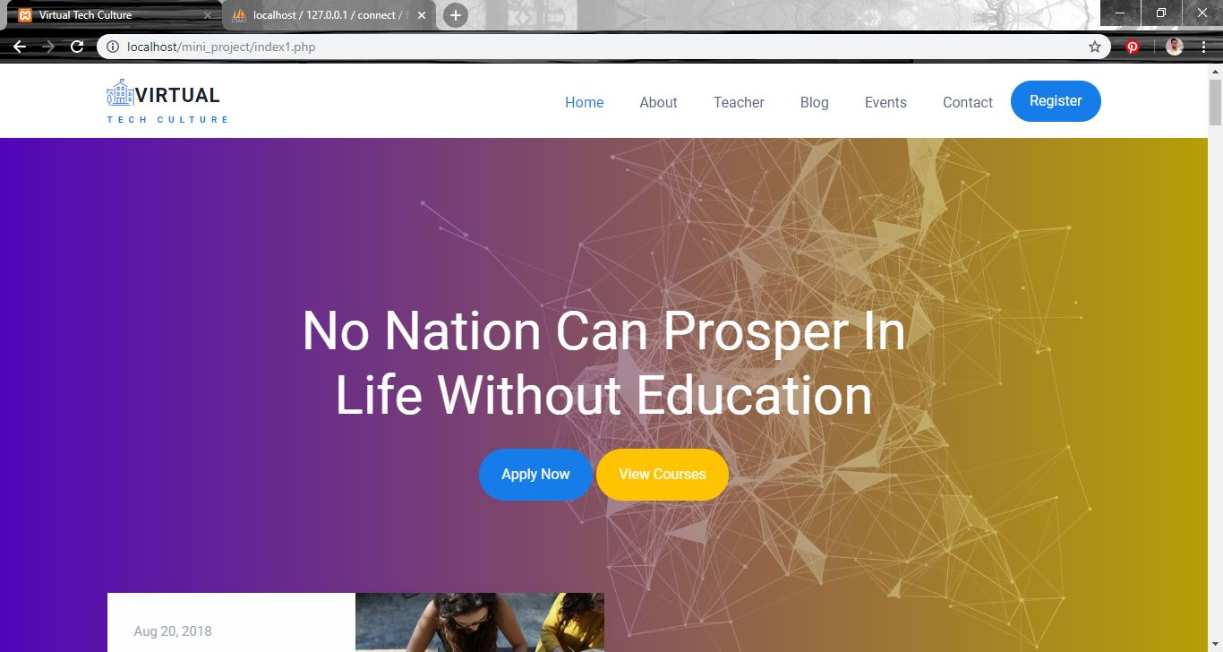

- Registration Page: user can register by creating account

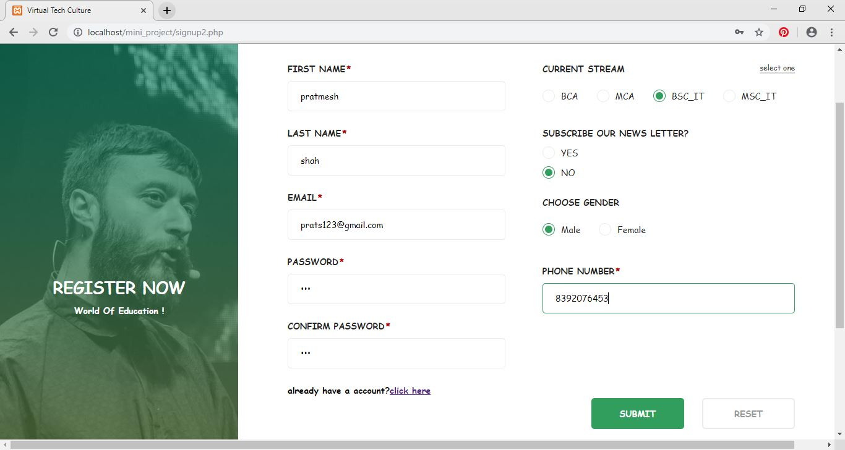

- Login Page: User can login by opening this page

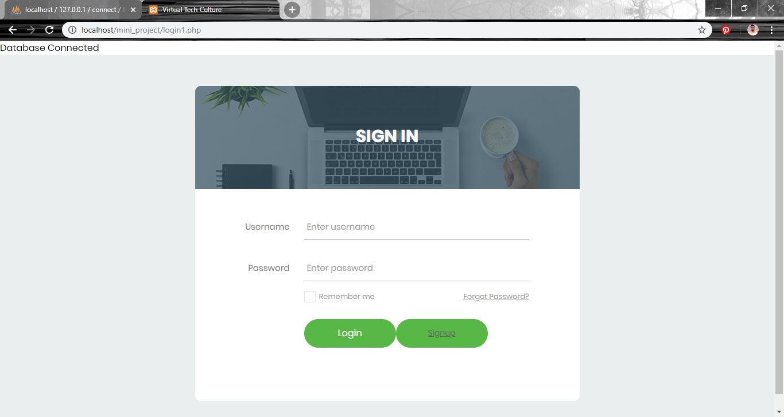

- Welcome Form: User can access materials and resources

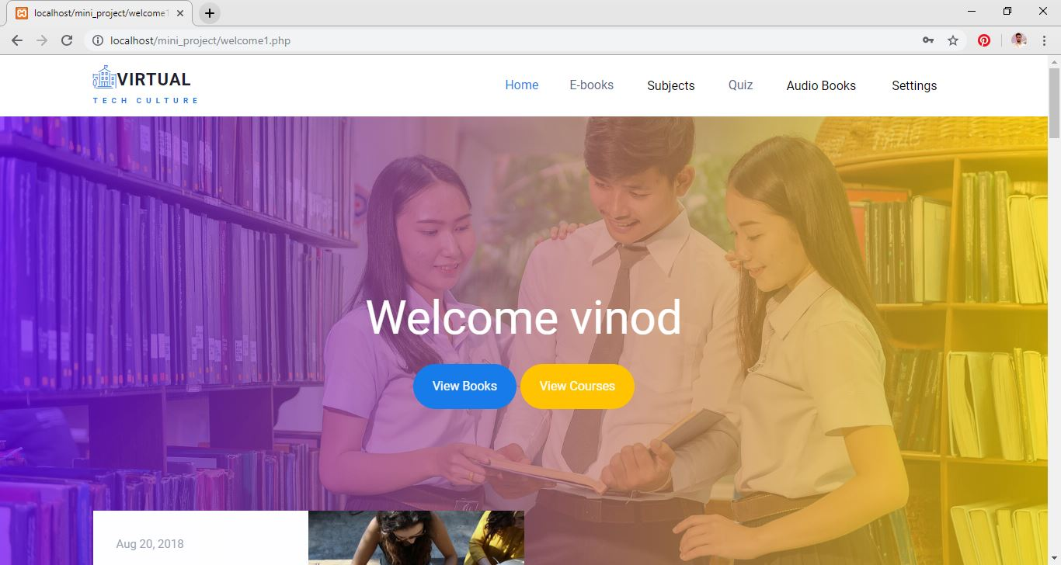

- Admin Panel: Home page for admin

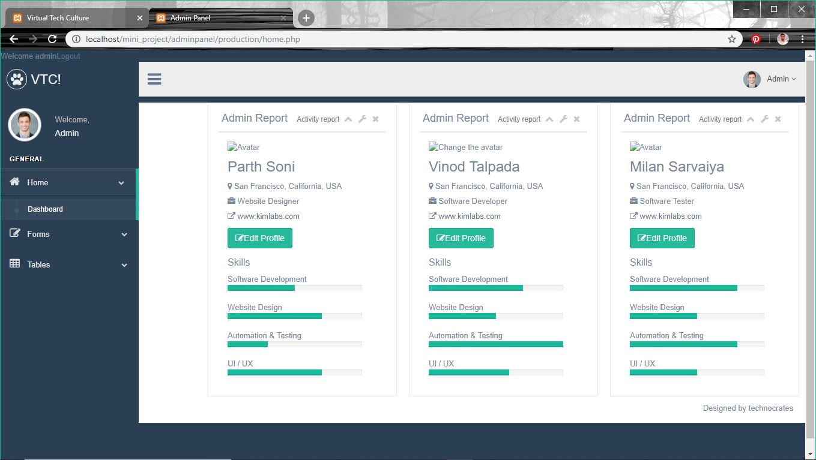

- Admin Panel: Login page for admin

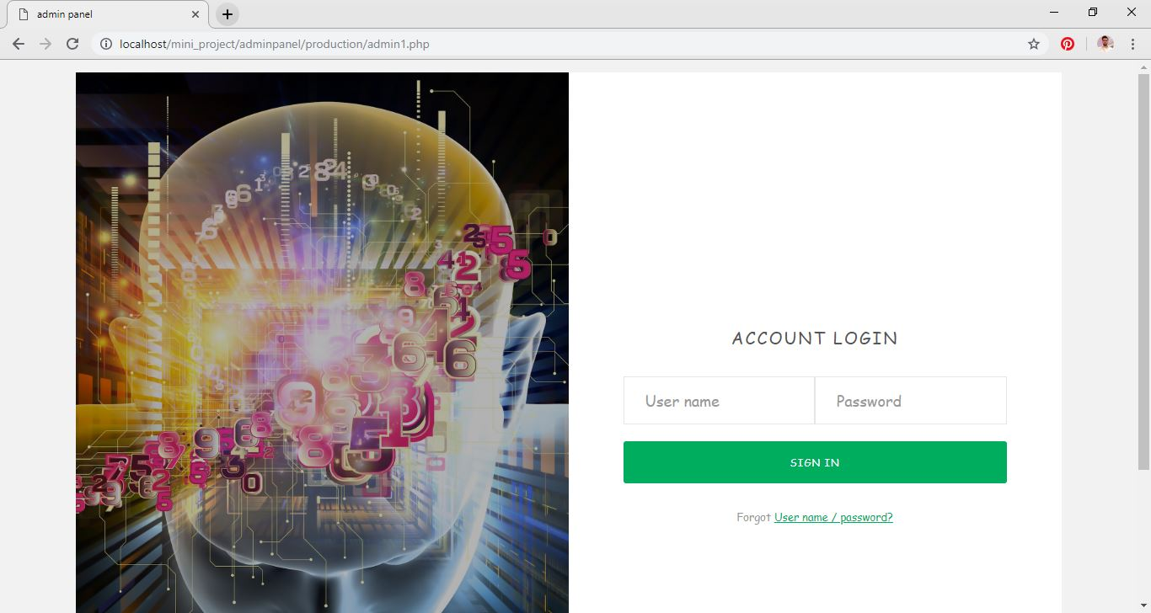

- Form Layout: Admin can upload, update images by this form.
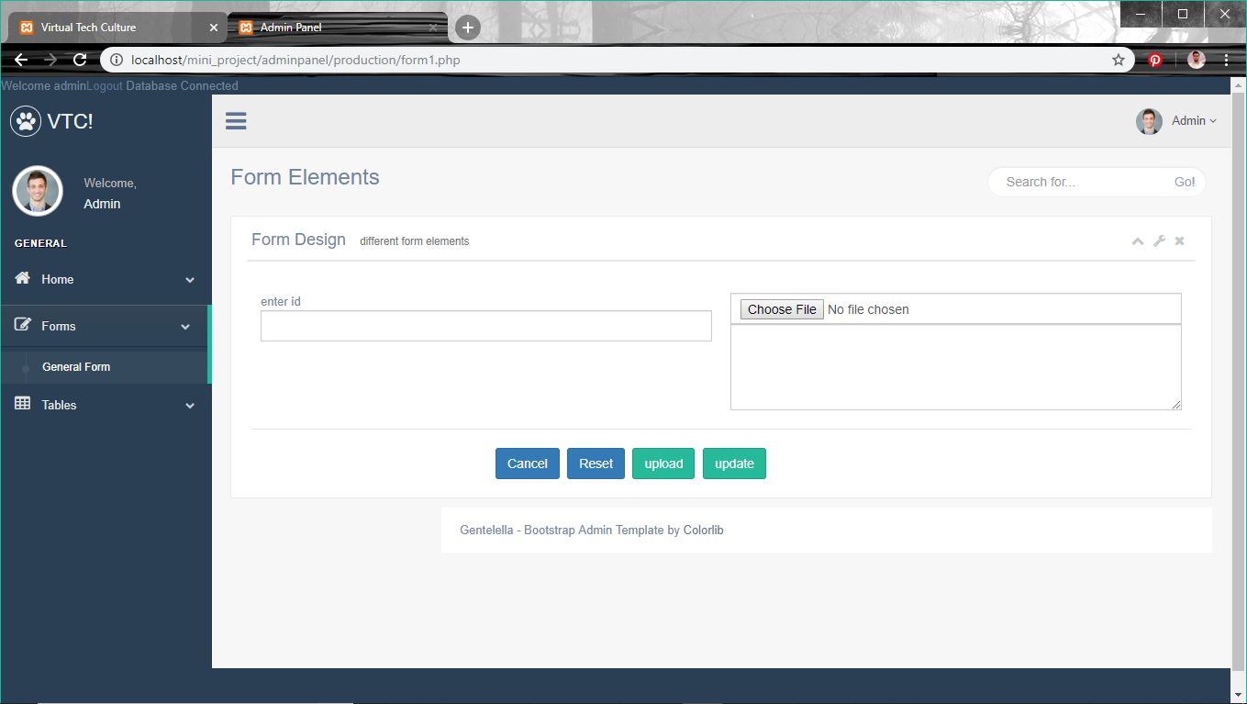
- Tables: Admin can view feedback of students.

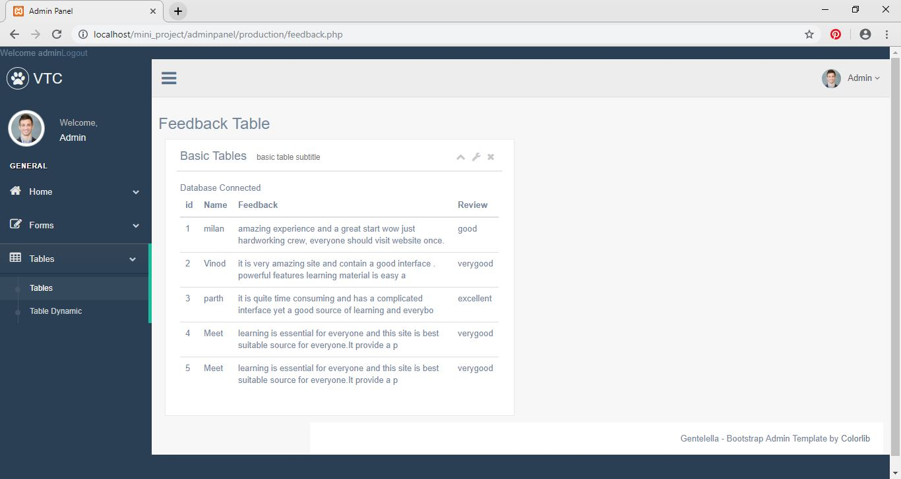

- Student registration Table: Admin can view registered students here.

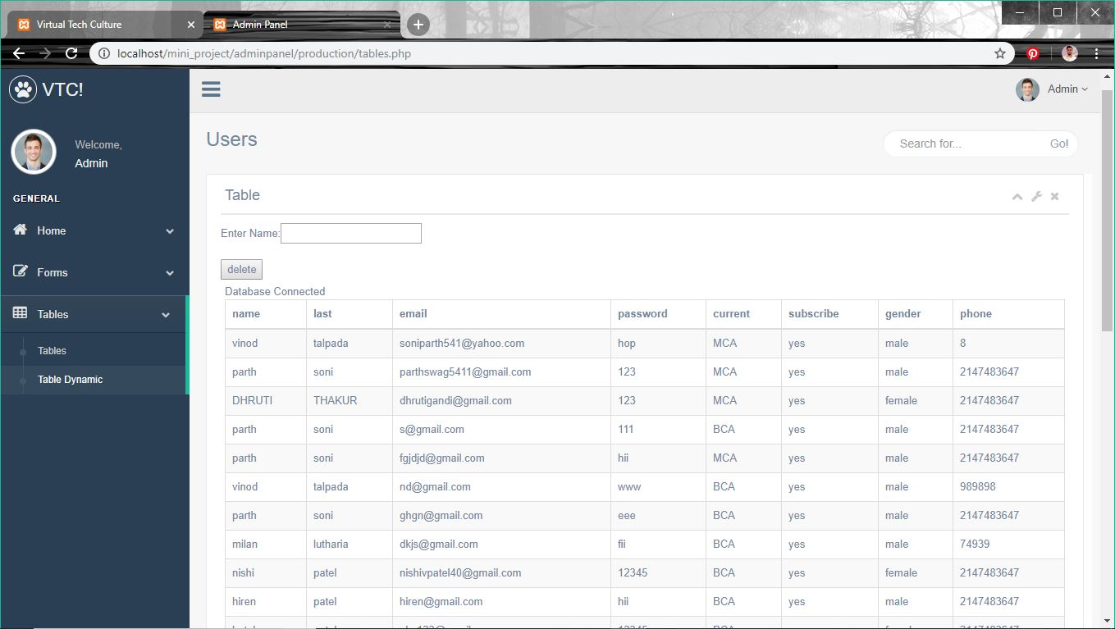

- Test cases:

Sr.no | Scenario | Purpose | Input | Expected Output | Status
1. | Clicking on submit button without filling any detail | Check whether it allows you to further proceed | Click Submit button | Alert notification for empty field | Success
2. | Enter Correct Login Details | To check valid username and password | Click on Login button | Invalid Username or Password | Success
3. | Destroy Session | It will logout successfully | Click on logout Button | Redirect to login page | Success
4. | Enter both passwords correctly | To authenticate both password | Click on submit button | Alert notification if password doesn`t match. | Success
5. | Receive mail | To send daily mail notifications | Click on subscribe button | Mail will not be received if user doesn`t subscribe | Success
6. | Delete Account | Delete user`s account | Click on delete link | Only registered users can delete their account | Success

- Future Enhancements:

- Chatting option can be added in which user can chat with experts and can solve their doubts.
- In future we can also develop android application for online learning website.
- We can also add actor like tutor who take live sessions and give assignments to students.

8. Bibliography /References:
  - www.w3schools.com
  - www.sourcecodester.com
  - www.colorlib.com

